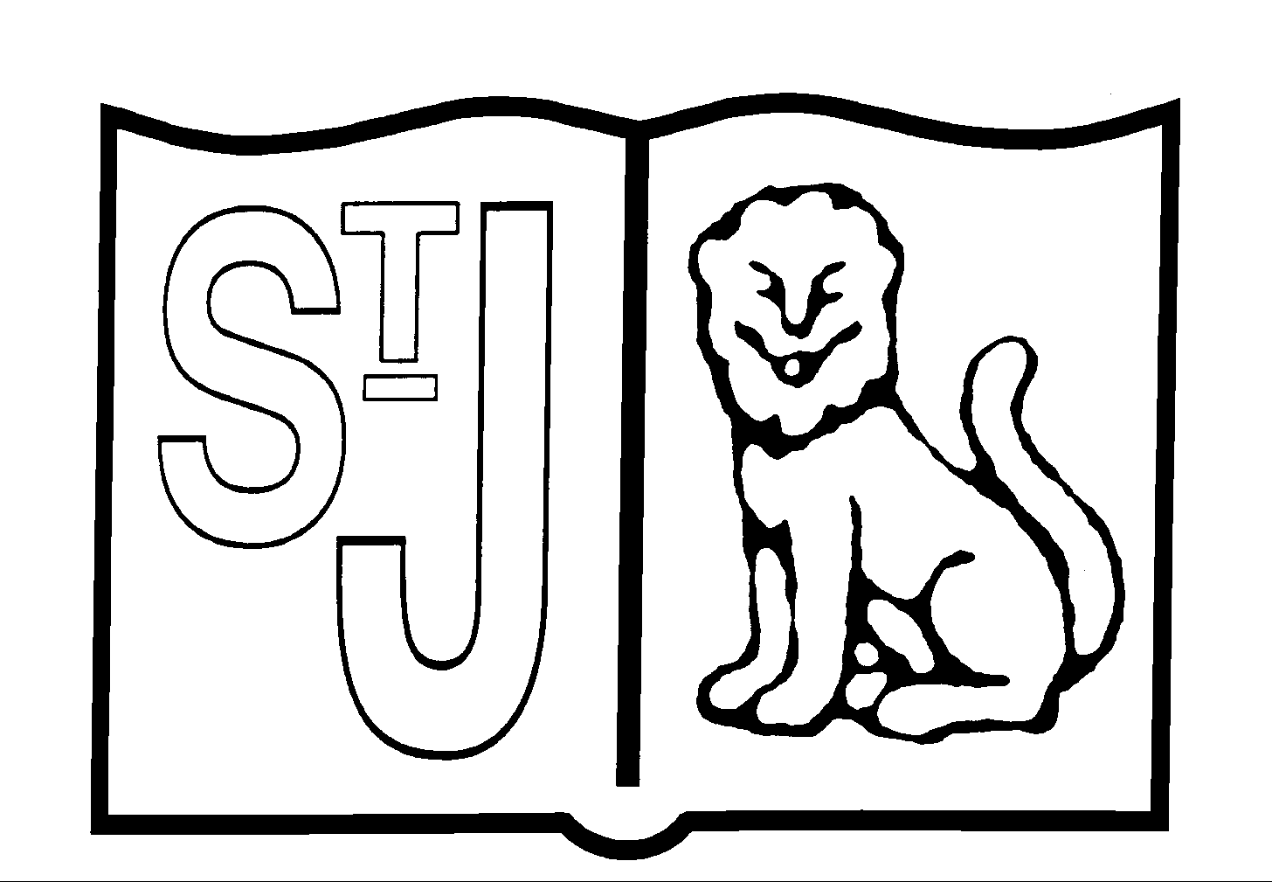
St Jerome’s Catholic Primary School
Art and Design Policy
Intent
Our vision for Art and Design is that we aim to inspire pupils and develop their confidence to experiment and invent their own works of art. We aim to give pupils every opportunity to develop their ability, nurture their talent and interests, express their idea and thoughts about the world, as well as learning about the rich heritage and culture of the British Isles and beyond.

Implementation
Learning in Art and Design at St. Jerome’s is delivered through the Kapow scheme of work. The Kapow Art scheme of work is designed with four strands that run throughout.
These strands are:
- Making skills
- Formal elements (line, shape, tone, texture, pattern, colour)
- Knowledge of artists
- Evaluating
These strands are revisited in every unit. In the art and design skills and formal elements of art units, pupils have the opportunity to learn and practise skills discretely. The knowledge and skills from these units are then applied throughout the other units in the scheme. Key skills are revisited again and again with increasing complexity in a spiral curriculum model. This allows pupils to revise and build on their previous learning.

The Curriculum overview document (Appendix 1) shows which units cover each of the National Curriculum attainment targets as well as each of the strands.

The Progression of skills document (Appendix 2) shows the skills that are taught within each year group and how these skills develop to ensure that attainment targets are securely met by the end of each key stage.

Kapow Primary’s Art and Design curriculum develops pupil’s knowledge and understanding of key artists and art movements through the ‘Every picture tells a story’ units and links to artists through practical work. The units fully scaffold and support essential and age appropriate sequenced learning. Creativity and independent outcomes are robustly embedded into the units, supporting pupils in learning how to make their own creative choices and decisions, so that their outcome, whilst being knowledge rich, are unique to the pupil and personal.

Lessons are practical in nature and encourage exploratory and experimental learning. Sketchbooks are used in Key Stage 1 and 2 by pupils to document their ideas.
Differentiated guidance is available for every lesson to ensure that lessons can be accessed an enjoyed by all pupils and opportunities to stretch pupil’s learning are available when required.

Knowledge organisers for each unit support pupils in building a foundation of factual knowledge by encouraging recall of key facts and vocabulary.

As part of the scheme pupil videos created by subject specialists help pupils to see art techniques modelled by experts.

Within each unit taught there are multiple teacher videos to develop subject knowledge and support CPD. This is to ensure that all teachers feel supported to deliver lessons of a high standard that ensure pupil progression.

In Key Stages 1 and 2 Art and Design is timetabled for 1 hour per week and extra sessions are provided where there are cross curricular opportunities for Art. In Reception (EYFS) weekly art activities are provided through continuous provision and planned for via focussed tasks.

Art equipment is stored centrally on the shelves in the Class 2 Resource Area, a variety of paper and equipment is located in the paper store cupboard by the Staff Room. Each key stage has their own supply of poster paint and glue.

Impact
Children will:
- Produce creative work, exploring and recording their ideas and experiences
- Be proficient in drawing, painting, sculpture and other art, craft and design techniques.
- Evaluate and analyse creative works using subject specific language.
- Know about great artists and the historical and cultural development of their art.
- Meet the end of key stage expectations outlined in the National curriculum for art and design.

The impact of the Art curriculum is constantly monitored through both formative and summative assessment opportunities. Each lesson in the scheme includes guidance to support teachers assessing pupils against learning objectives.

After the implementation of the Art and Design scheme, pupils should leave primary school equipped with a range of techniques and the confidence and creativity to form a strong foundation for their Art and design learning at Key Stage 3 and beyond.

Additional Art teaching
Art activities are taken outside where appropriate within the school grounds or as part of Beach School where we look at environmental art, nature and sculpture. We look at the work of the artists and sculptors Andrew Goldsworthy, Anthony Gormley and local artist Simon Archer.

St. Jerome’s has two extra-curricular art clubs. After school Art Club is run by Mrs Button in Key stage 2 and Mrs Pritchard and Mrs Clarke run Craft Club in Key Stage 1 at lunch time

Assessment
Children demonstrate their ability in Art in a variety of different ways. Teachers will assess children’s work in Art by making informal judgements as they observe them during lessons. On completion of a piece of work, the teacher will assess the work and give oral feedback. Older and more able pupils are encouraged to make judgements about how they can improve their own work.

Individual children’s sketch books, photographs and displays of children’s work will provide evidence for assessment. The Art and Design Progression Map will enable teachers to assess whether children are working below, above or at the expected level at the end of each year. Interim judgements will be made after each unit of work (half termly) and recorded on Balance.

Equal opportunities and Inclusion
Activities both inside and outside the classroom are planned in such a way that encourages full and active participation for all children. The class teacher provides teaching and learning that is appropriate for all children including those with SEN and gifted and talented pupils.

Activities should be carefully planned by the class teacher and be differentiated where appropriate for children with SEN and equally the more able and Gifted and Talented children. All resources/materials have been reviewed with equal opportunities in mind, e.g. race, gender, ethnicity. The range of skills and techniques studied at each stage of learning should present opportunities for children to gain an understanding of arts and crafts from the past and from varying cultures.

Resources
Art equipment is stored centrally on the shelves in the Class 2 Resource Area. A variety of equipment can be located in the Staff Paper store by the Staff Room. Each Key Stage has their own supply of paint and glue.
Visual refence materials (in addition to online resources) are stored in the library and Staff Winter Garden.

Health and Safety
Children are taught to use materials, tools and equipment safely in line with the school Health and Safety Policy. Children are required to wear protective clothing when working with wet media such as glue, paint, printing ink, dyes, clay and plaster. Children are taught to clear away practical materials responsibly. The use of tools and equipment is closely supervised by teachers and sharp tools are introduced appropriately.

Role of the Subject Leader
The coordination and planning of the Art and Design curriculum are the responsibility of the subject leader, who also:
- keeps colleagues and school governors informed about developments in Art and Design and provides a strategic lead and direction for the subject;
- keeps own CPD up-to-date and regularly feeds back to colleagues;
- discusses progress with the Head Teacher and evaluates strengths and weaknesses in Art and Design;
- reviews the success of the Kapow Art scheme and reviews evidence of children’s work;

Updated: June 2023 Review: June 2024

