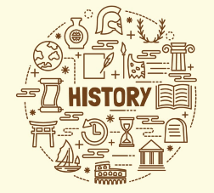

**Key Individual**

Guy Fawkes (1570)

Marie Curie (1867)

Grace O’Malley (1530)

Malala Yousafzai (1997)

**Year 1 Who is the greatest historian?**

**Subject Specific Skills**

* Tell us about an important historical event that happened in the past.
* Explain differences between past and present in their life and that of other children from a different time in history.
* Find answers to simple questions about the past from sources of information.

**Prior Learning**

* I have talked about past and present events.
* I know that other children don’t always enjoy the same things.
* I know about similarities and differences between myself and others, and among families, communities and traditions.

**Key Knowledge**

* **Reflect** upon what history makers might achieve during the remainder of this century and **describe** and **explain** what they might wish to be remembered for in the future – the mark they would wish to leave on history;

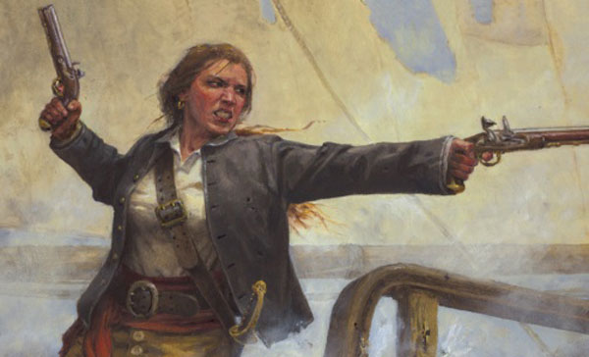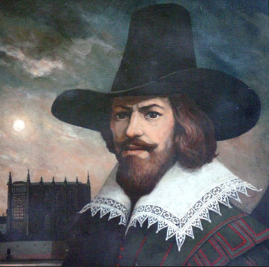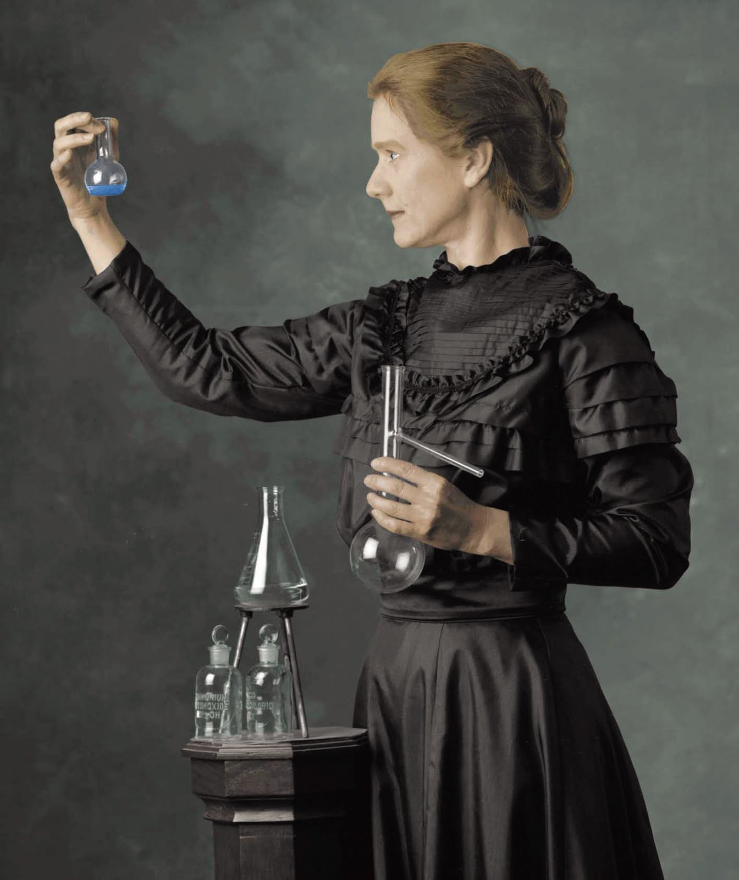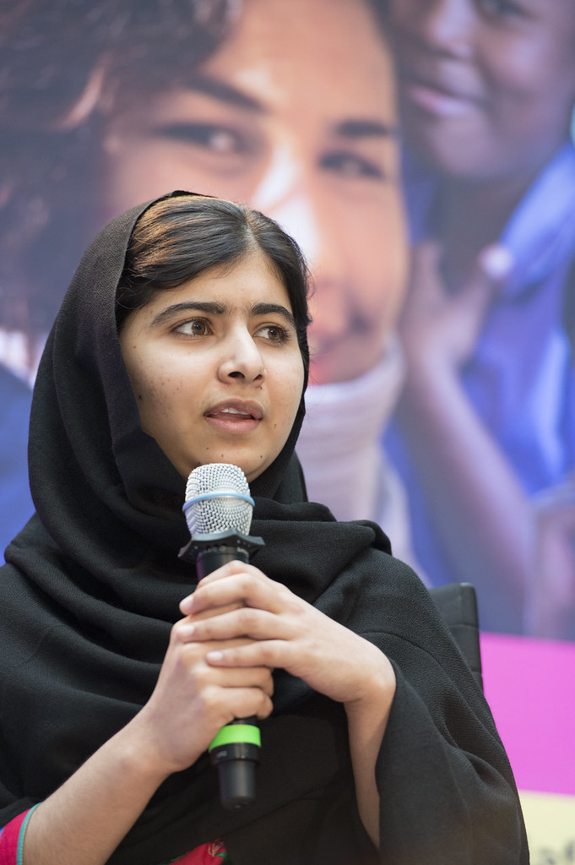

**Key Vocabulary**

Guy Fawkes Night; Bonfire Night; Firework Night; assassinate; King James I; Parliament; cellar; gunpowder; equal rights, scientist; Paris; student; research; experiment; investigation; fact; ; Nobel Peace prize; X-ray machine; doctor; injured; illness; treatment; front line; soldier; Pakistan; proud; powerful; accomplished, Muslim; Birmingham; childhood; study; president, religion; demolish; diary; schoolgirl, weapon, pirate, seize, enemy, invasion.

**Key Knowledge**

* **Identify**, **describe** and **explain** what is commemorated on Guy Fawkes Night, 5 November every year in the United Kingdom;
* **Describe**, **reason** and **explain** what it means for someone such as Guy Fawkes/Marie Curie to make history, that is, doing something so significant (good or bad and that may not have been done before) and that is remembered and studied for a long time because of the effect they had on other people’s lives, beliefs or ideas;
* **Identify, describe** and **explain** how four significant people made history during their lifetime. Look at profiles of Guy Fawkes, Grace O’Malley, Malala Yousafzai and Marie Curie. Discuss how long ago each lived and whereabouts in the world. Are any are still living? Who lived the longest ago? Order on a timeline.
* **Compare and contrast** the achievements of these individuals, producing a rank order of historical importance **explaining** and **justifying** their decision;