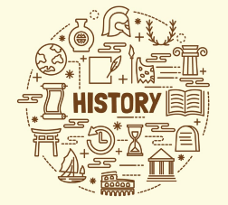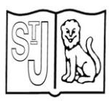

**Prior Learning**

* Events beyond living memory that are significant nationally or globally [for example, the Great Fire of London, the first aeroplane flight or events commemorated through festivals or anniversaries]
* Significant historical events, people and places in their own country.

**Year 6 History**

**Knowledge Organiser**

**The History of York**

**Subject Specific Skills**

* Know and understand the history of these islands as a coherent, chronological narrative, from the earliest times to the present day: how people’s lives have shaped this nation and how Britain has influenced and been influenced by the wider world
* A history study, tracing how several aspects of national history are reflected in the locality (this can go beyond 1066).

**Key Knowledge**

The third enquiry enables pupils to understand how funds were raised to finance the construction of the cathedral and the consequent sacrifices that had to be made by ordinary people through the payment of tithes and the gifting of voluntary and unpaid labour. It culminates in pupils designing a sculpture to sit outside the entrance to the cathedral, to commemorate the efforts of all those people who contributed to its construction over a period of two centuries and who today remain anonymous.

On 22 July 1644, during the English Civil War, the largest battle ever fought on English soil took place at Marston Moor, a few kilometres outside of York. Here, the Cavalier armies of King Charles I, led by the Marquis of Newcastle and Prince Rupert of the Rhine, faced the Parliamentarian forces of Lord Fairfax, under whom Oliver Cromwell was serving as a cavalry officer. In addition to being able to understand the events of the battle, which culminated in a Parliamentarian victory, pupils are also supported to investigate another fascinating aspect of the clash – the role of a dog called Boye.

The final enquiry examines two important effects of the coming of the industrial age to York in the early 1800s: the influence of the arrival of the railway and the growth of large factories in which products were manufactured for the first time using steam-driven machinery. An investigation of the York Rowntree confectionery factory enables pupils to consider how the Quaker beliefs of social reform and the philanthropy of its owner manifested themselves in enlightened working conditions. These lay in stark contrast to the circumstances encountered in most other Victorian industrial plants of the times, where child labour and exploitative practices were common.

**Key Individual**

Geta (189AD – 211AD)

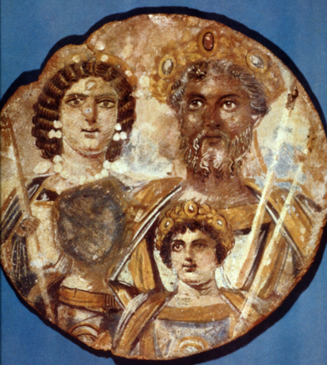

Oshere (Around 750AD)

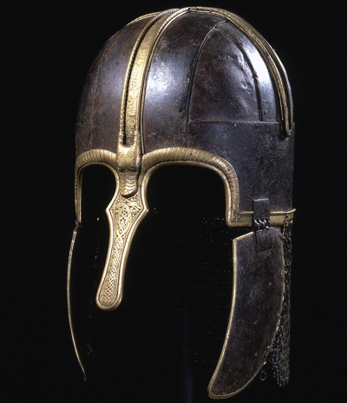

Boye (1638AD – 1644AD)

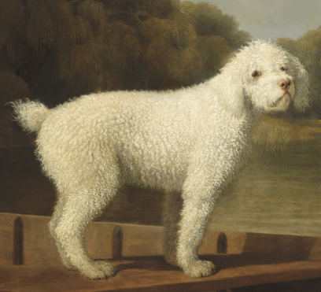

**Key Vocabulary**

Ceramic; head pot; Roman; York; Eboracum; Caracalla; Antoninus; Geta; reconciliation; assassinated; Praetorian Guard; archaeologist; battle of Dun Nechtain; Anglo-Saxon; Eoferwic; helmet; artefact; iron; brass; Oshere; nobleman; Prince; violence; York Minster; Roman Catholic Church; Gothic; architecture; superiority; culture; tax; tithe; sacrifices; Battle of Marston Moor; Boye; Prince Rupert of the Rhine; Oliver Cromwell; civil war; King Charles I; Cavaliers; Roundheads; industry; railway; London; Edinburgh; employees; Industrial Revolution; steam engine; James Watt; working conditions; child labour; Factory Act; Mines Act; Joseph Rowntree; Quaker; philanthropist.

**Key Knowledge**

The investigation consists of five ancillary questions that span a timeline of 1,600 years.

The first enquiry focuses on the Roman occupation of York and in particular the legacy and internal family feuding of one emperor, known as the ‘African Emperor’, who lived in and ruled the entire Roman Empire from York for a few years at the beginning of the third century. On his death, the Roman Empire was co-ruled for a while by his two sons – Antoninus (commonly known as Caracalla) and Geta. Following the assassination of Geta by his brother, all records of his sibling, including his image, were expunged, by order of Caracalla. Can pupils recreate his picture from the many shards of broken head pots discovered at York?

The second investigation presents pupils with an Anglo-Saxon mystery to solve from the seventh century. The discovery at Coppergate in the 1980s of the magnificent ‘York helmet’, which archaeologists believe to have belonged to a Northumbrian nobleman called Oshere, has raised many intriguing questions. In particular, it appears that the helmet was carefully hidden by Oshere in a manner that would suggest he was almost certainly going to return for it. But the fact that he didn’t presents a mystery for pupils to try to solve from the limited evidence available.