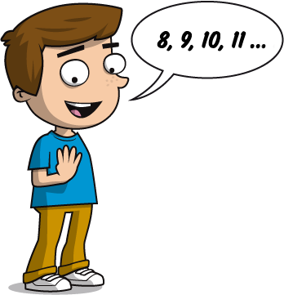
 Overview of Strategies and Methods – Addition

 | Year 1 | Year 2
Mental Addition | Using place value  Count in 1s  e.g. 45 + 1  Count in 10s  e.g. 45 + 10 without counting on in 1s  34 35 36  44 46  54 55 56  Add 10 to any given 2-digit number  Counting on  Count on in 1s  e.g. 8 + 3 as 8, 9, 10, 11  Add, putting the larger number first Count on in 10s  e.g. 45 + 20 as 45, 55, 65 | Using place value  Know 1 more or 10 more than any number  e.g. 1 more than 67  e.g. 10 more than 85  Partitioning  e.g. 55 + 37 as 50 + 30 and 5 + 7, then finally combine the two  totals: 80 + 12  50 + 30 = 80  5 5 + 3 7 9 2  5 + 7 = 1 2  Counting on  Add 10 and multiples of 10 to a given 1- or 2-digit number e.g. 76 + 20 as 76, 86, 96 or in one hop: 76 + 20 = 96  Add two 2-digit numbers by counting on in 10s, then in 1s e.g. 55 + 37 as 55 + 30 (85) + 7 = 92  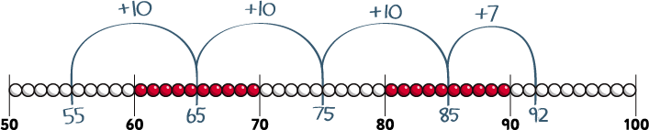  Add near multiples of 10  e.g. 46 + 19  e.g. 63 + 21


Overview of Strategies and Methods – Addition
 | Year 1 | Year 2
Mental Addition | Using number facts  ‘Story’ of 4, 5, 6, 7, 8 and 9  e.g. 7 = 7 + 0, 6 + 1, 5 + 2, 4 + 3  Number bonds to 10  e.g. 5 + 5, 6 + 4, 7 + 3, 8 + 2, 9 + 1, 10 + 0  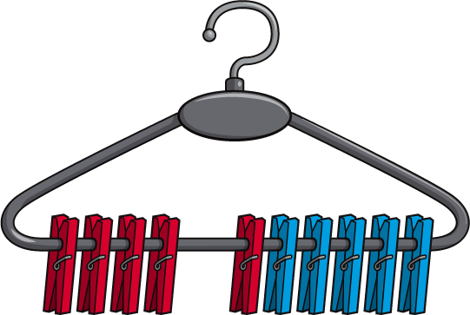  4 + 6 = 10  Use patterns based on known facts when adding e.g. 4 + 3 = 7 so we know 24 + 3, 44 + 3, 74 + 3 | Using number facts  Know pairs of numbers which make the numbers up to and including 12  e.g. 8 = 4 + 4, 3 + 5, 2 + 6, 1 + 7, 0 + 8  e.g. 10 = 5 + 5, 4 + 6, 3 + 7, 2 + 8, 1 + 9, 0 + 10  Use patterns based on known facts when adding  e.g. 6 + 3 = 9, so we know 36 + 3 = 39, 66 + 3 = 69, 56 + 3 = 59  Bridging 10  e.g. 57 + 5 = 57 + 3 (60) + 2 = 62  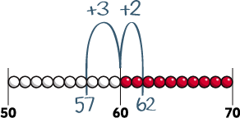  Add three or more 1-digit numbers, spotting bonds to 10 or doubles e.g. 3 + 5 + 3 = 6 + 5 = 11  e.g. 8 + 2 + 4 = 10 + 4 = 14


Overview of Strategies and Methods – Subtraction

 | Year 1 | Year 2
Mental Subtraction | Using place value  Count back in 1s  e.g. Know 53 – 1  Count back in 10s  e.g. Know 53 – 10 without counting back in 1s  32 33 34  42 43 44  52 53 54  Taking away  Count back in 1s  e.g. 11 – 3 as 11, 10, 9, 8  e.g. 14 – 3 as 14, 13, 12, 11  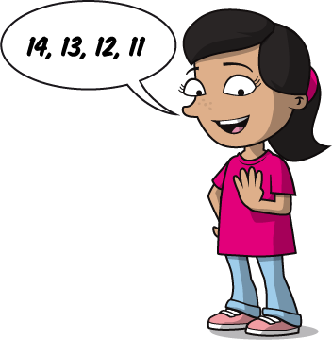  Count back in 10s  e.g. 53 – 20 as 53, 43, 33 | Using place value  Know 1 less or 10 less than any number  e.g. 1 less than 74  e.g. 10 less than 82  Partitioning  e.g. 55 – 32 as 50 – 30 and 5 – 2 and combine the answers: 20 + 3  50 – 30 = 20  5 5 – 3 2 2 3  5 – 2 = 3  Taking away  Subtract 10 and multiples of 10  e.g. 76 – 20 as 76, 66, 56 or in one hop: 76 – 20 = 56  Subtract two 2-digit numbers by counting back in 10s, then in 1s  e.g. 67 – 34 as 67 subtract 30 (37) then count back 4 (33)  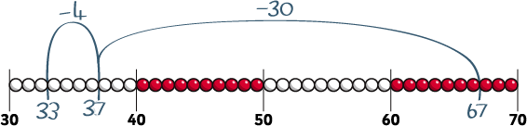  Subtract near multiples of 10  e.g. 74 – 21  e.g. 57 − 19


Overview of Strategies and Methods – Subtraction
 | Year 1 | Year 2
Mental Subtraction | Using number facts  ‘Story’ of 4, 5, 6, 7, 8 and 9  e.g. ‘Story’ of 7 is 7 – 1 = 6, 7 – 2 = 5, 7 – 3 = 4  Number bonds to 10  e.g. 10 – 1 = 9, 10 – 2 = 8, 10 – 3 = 7  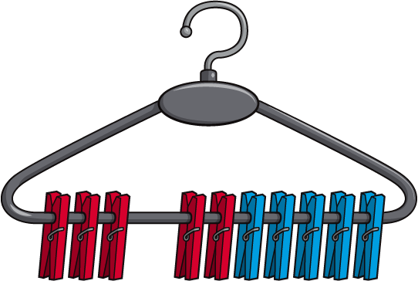  10 – 7 = 3  Subtract using patterns of known facts  e.g. 7 – 3 = 4 so we know 27 – 3 = 24, 47 – 3 = 44, 77 – 3 = 74 | Using number facts  Know pairs of numbers which make the numbers up to and including 12 and derive related subtraction facts  e.g. 10 – 6 = 4, 8 – 3 = 5, 5 – 2 = 3  Subtract using patterns of known facts  e.g. 9 – 3 = 6, so we know 39 – 3 = 36, 69 – 3 = 66, 89 – 3 = 86  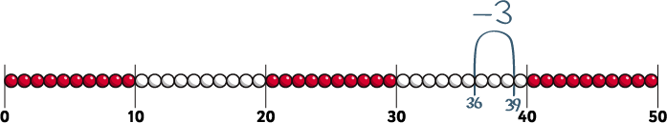  Bridging 10  e.g. 52 – 6 as 52 – 2 (50) – 4 = 46  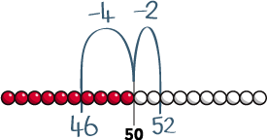  Counting up  Find a difference between two numbers on a line where the numbers are close together  e.g. 51 – 47

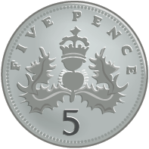
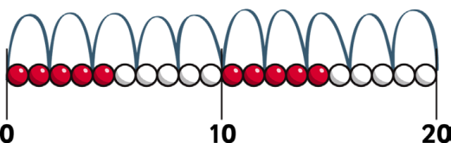
 | Year 1 |  |  |  | Year 2
Mental Multiplication | Counting in steps (‘clever’ counting)  Count in 2s  2 2 2 2 2 2 2 2 2  Count in 10s  1 2 3 4 5 6 7  11 12 13 14 15 16 17  21 22 23 24 25 26 27  31 32 33 34 35 36 37  41 42 43 44 45 46 47  51 52 53 54 55 56 57  61 62 63 64 65 66 67  71 72 73 74 75 76 77  81 82 83 84 85 86 87  91 92 93 94 95 96 97 | 2  8  18  28  38  48  58  68  78  88  98 | 9  19  29  39  49  59  69  79  89  99 | 10  20  30  40  50  60  70  80  90  100 | Counting in steps (‘clever’ counting)  Count in 2s, 5s and 10s  5 5 5 5 5 5  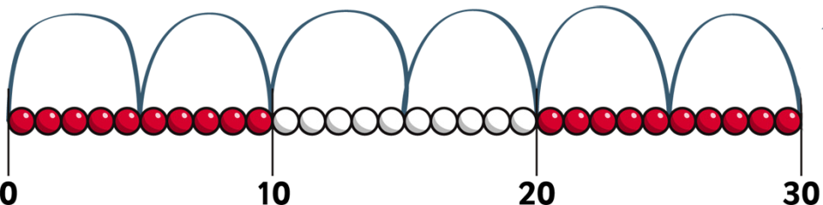  Begin to count in 3s  Doubling and halving  Begin to know doubles of multiples of 5 to 100  e.g. double 35 is 70  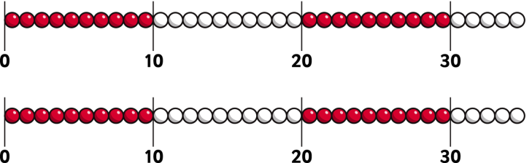  Begin to double 2-digit numbers less than 50 with 1s digits of 1, 2, 3, 4 or 5


Overview of Strategies and Methods – Multiplication
 | Year 1 | Year 2
Mental Multiplication | Doubling and halving  Find doubles to double 5 using fingers  e.g. double 3  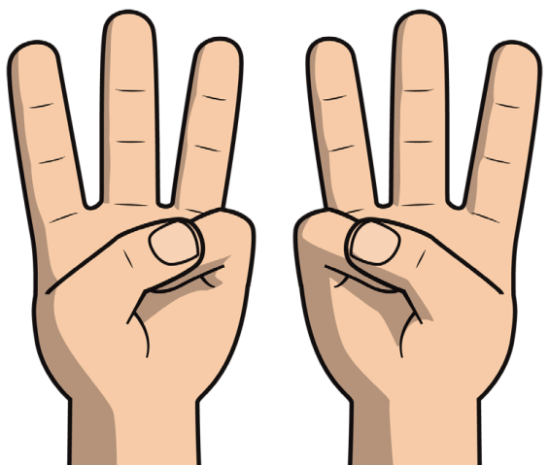 | Grouping  Use arrays to find answers to multiplication and relate to ‘clever’ counting  e.g. 3 × 4 as three lots of four things  e.g. 6 × 5 as six steps in the 5s count as well as six lots of five  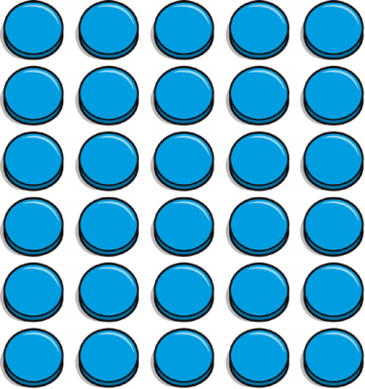  5 5 5 5 5 5  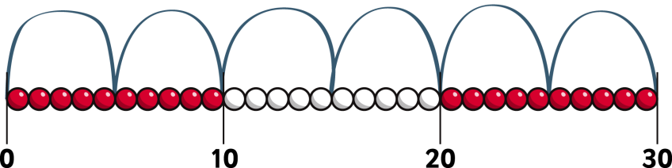  Understand that 5 × 3 can be worked out as three 5s or five 3s


Overview of Strategies and Methods – Multiplication
 | Year 1 | Year 2
Mental Multiplication | Grouping  Begin to use visual and concrete arrays and sets of objects to find the answers to ‘three lots of four’ or ‘two lots of five’  e.g. three lots of four  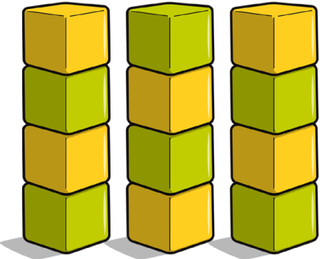  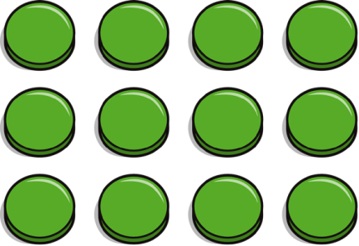 | Using number facts  Know doubles to double 20  e.g. double 7 is 14  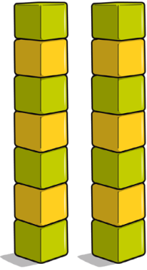  Start learning ×2, ×5, ×10 tables, relating these to ‘clever’ counting in 2s, 5s, and 10s  e.g. 5 × 10 = 50, and five steps in the 10s count = 10, 20, 30, 40, 50  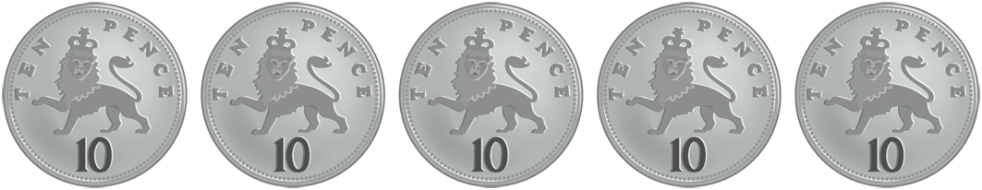

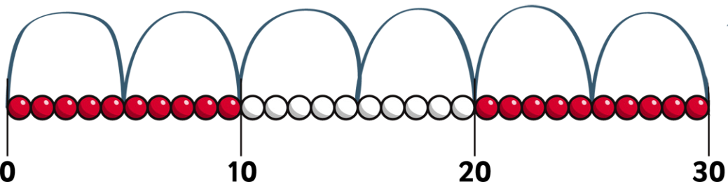
Overview of Strategies and Methods – Division
 | Year 1 | Year 2
Mental Division | Counting in steps (‘clever’ counting)  Count in 2s  2 2 2 2 2 2 2 2 2 2  Count in 10s  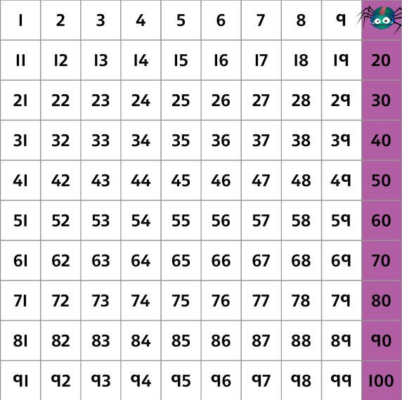  Doubling and halving  Find half of even numbers up to 12, including realising that it is hard to halve an odd number  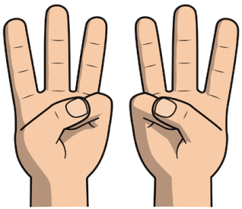 | Counting in steps (‘clever’ counting)  Count in 2s, 5s and 10s  5 5 5 5 5 5  Begin to count in 3s  Doubling and halving  Find half of numbers up to 40, including realising that half of an odd number gives a remainder of 1 or an answer containing a 1/2  e.g. 1/2 of 11 = 5 1/2  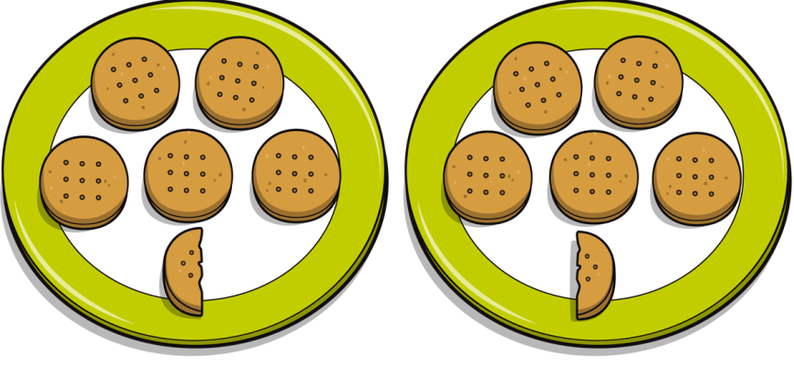  Begin to know half of multiples of 10 to 100  e.g. half of 70 is 35


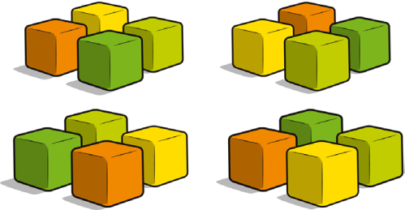
Overview of Strategies and Methods – Division
 | Year 1 | Year 2
Mental Division | Grouping  Begin to use visual and concrete arrays and ‘sets of’ objects to find the answers to questions such as ‘How many towers of three can I make with twelve cubes?’  Sharing  Begin to find half of a quantity using sharing  e.g. find half of 16 cubes by giving one each repeatedly to two children | Grouping  Relate division to multiplication by using arrays or towers of cubes to find answers to division  e.g. ‘How many towers of five cubes can I make from twenty cubes?’ as _ × 5 = 20 and also as 20 ÷ 5 = _  Relate division to ‘clever’ counting and hence to multiplication  e.g. ‘How many fives do I count to get to twenty?’  Sharing  Begin to find half or a quarter of a quantity using sharing  e.g. find a quarter of 16 cubes by sorting the cubes into four piles  Find 1/4, 1/2, 3/4 of small quantities  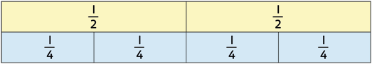  Using number facts  Know half of even numbers to 24 Know ×2, ×5 and ×10 division facts Begin to know ×3 division facts

